Problem 5. TREE

Vertex enumeration of a tree is any sequence whose elements are vertices of that tree and every vertex appears exactly once. If any two consecutive elements in the sequence are vertices whose graph distance is not greater than d this vertex enumeration is called d-enumeration. For any tree there is a 3-enumeration. Write a program ZAD5.EXE which finds a 3-enumeration for a given tree.

INPUT: In the first line of input text file ZAD5.DAT is the number n (1 ≤ n ≤ 30000), the number of vertices in the tree. Vertices are denoted by numbers from 1 to n. In the next n-1 lines there are two integers which determine one edges of the tree.

OUTPUT: In every of n lines of output text file ZAD5.RES there is an integer which is element of the 3-enumeration of the given tree in the same order as in enumeration.

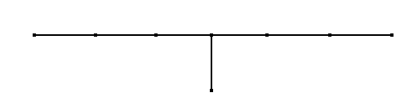
EXAPMLE:
1 4 6 7 2 5 3

8

ZAD5.DAT ZAD5.RES
8 3
1 4 2
4 6 6
6 7 1
3 5 4
7 2 8
2 5 7
8 7 5

